OSPF DMVPN IPSEC

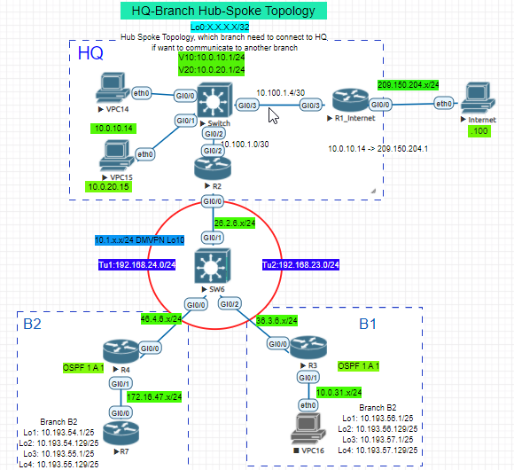

Loopback10 10.1.x.x/24

OSPF

R2#sh run | sec router ospf

router ospf 111

router-id 10.1.2.2

network 10.1.2.0 0.0.0.255 area 0

network 10.100.1.0 0.0.0.3 area 0

network 172.16.1.0 0.0.0.255 area 0

R3#sh run | sec router

router ospf 111

router-id 10.1.3.3

area 1 nssa no-summary

area 1 range 10.193.56.0 255.255.254.0

network 10.1.3.0 0.0.0.255 area 1

network 10.193.56.0 0.0.0.127 area 1

network 10.193.56.128 0.0.0.127 area 1

network 10.193.57.0 0.0.0.127 area 1

network 10.193.57.128 0.0.0.127 area 1

network 172.16.1.0 0.0.0.255 area 0

R4#sh run | sec router

router ospf 111

router-id 10.1.4.4

area 1 nssa no-summary

area 1 range 10.193.54.0 255.255.254.0

network 10.1.4.0 0.0.0.255 area 1

network 172.16.1.0 0.0.0.255 area 0

network 172.16.47.0 0.0.0.255 area 1

R7#sh run | sec router

router ospf 1

router-id 10.1.7.7

area 1 nssa

network 10.1.7.0 0.0.0.255 area 1

network 10.193.54.0 0.0.0.127 area 1

network 10.193.54.128 0.0.0.127 area 1

network 10.193.55.0 0.0.0.127 area 1

network 10.193.55.128 0.0.0.127 area 1

network 172.16.47.0 0.0.0.255 area 1

IPSEC

crypto isakmp policy 10

hash md5

authentication pre-share

crypto isakmp key cisco123 address 0.0.0.0

!

!

crypto ipsec transform-set strong esp-3des esp-md5-hmac

mode tunnel

!

crypto ipsec profile cisco

set security-association lifetime seconds 120

set transform-set strong

DMVPN TUNNEL

R2#?interface Tunnel0

ip address 172.16.1.2 255.255.255.0

no ip redirects

ip mtu 1400

ip nhrp authentication gmlabs

ip nhrp map multicast dynamic

ip nhrp network-id 111

ip nhrp shortcut

ip nhrp redirect

ip ospf network point-to-multipoint

tunnel source GigabitEthernet0/0

tunnel mode gre multipoint

tunnel key 123

tunnel protection ipsec profile cisco

end

R3?interface Tunnel0

ip address 172.16.1.3 255.255.255.0

no ip redirects

ip mtu 1400

ip nhrp authentication gmlabs

ip nhrp map 172.16.1.2 26.2.6.2

ip nhrp map multicast 26.2.6.2

ip nhrp network-id 111

ip nhrp holdtime 60

ip nhrp nhs 172.16.1.2

ip nhrp registration timeout 30

ip nhrp shortcut

ip ospf network point-to-multipoint

tunnel source GigabitEthernet0/0

tunnel mode gre multipoint

tunnel key 123

tunnel protection ipsec profile cisco

end

R4?interface Tunnel0

ip address 172.16.1.4 255.255.255.0

no ip redirects

ip mtu 1400

ip nhrp authentication gmlabs

ip nhrp map 172.16.1.2 26.2.6.2

ip nhrp map multicast 26.2.6.2

ip nhrp network-id 111

ip nhrp holdtime 60

ip nhrp nhs 172.16.1.2

ip nhrp registration timeout 30

ip nhrp shortcut

ip ospf network point-to-multipoint

tunnel source GigabitEthernet0/0

tunnel mode gre multipoint

tunnel key 123

tunnel protection ipsec profile cisco

end

NAT

R1_Internet#

router ospf 1

network 1.1.1.1 0.0.0.0 area 0

network 10.100.1.4 0.0.0.3 area 0

default-information originate

interface GigabitEthernet0/0

ip nat outside

interface GigabitEthernet0/3

ip nat inside

ip nat inside source list 1 interface GigabitEthernet0/0 overload

access-list 1 permit 10.193.54.0 0.0.0.255

access-list 1 permit 10.193.56.0 0.0.0.255